THE INNER WORKINGS OF A SIPHON
Jacques Chaurette p. eng.
www.lightmypump.com
January 2003

Synopsis

The objective of this article is to explain how a siphon works. The difference between low pressure, atmospheric pressure and pressure is explained. The different pressure measurement units are discussed as well as the variation in atmospheric pressure depending on location or elevation with respect to sea level. The readers will be able to perform many experiments helping explain these concepts with easily available materials. Seems like allot to explain the behavior of a simple siphon, that is because all is not as it appears.

A siphon is a pipe or tubing system that allows transfer of fluid from an upper location to a lower one; the key feature of a siphon is that the fluid is moved upwards from its entry point before it turns down to its exit point. To all appearances it seems as if the fluid is being magically raised upwards without the use of a pump.

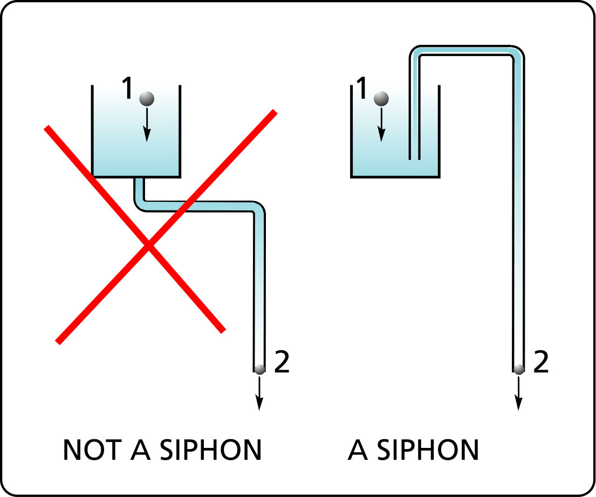
Figure 1 What is a siphon is not.

This is all very interesting but what importance can this possibly have? If you notice, a siphon is just like a typical pump system that is transferring fluid to an upper level and coming into a tank from above as is often the case (see Figure 2).
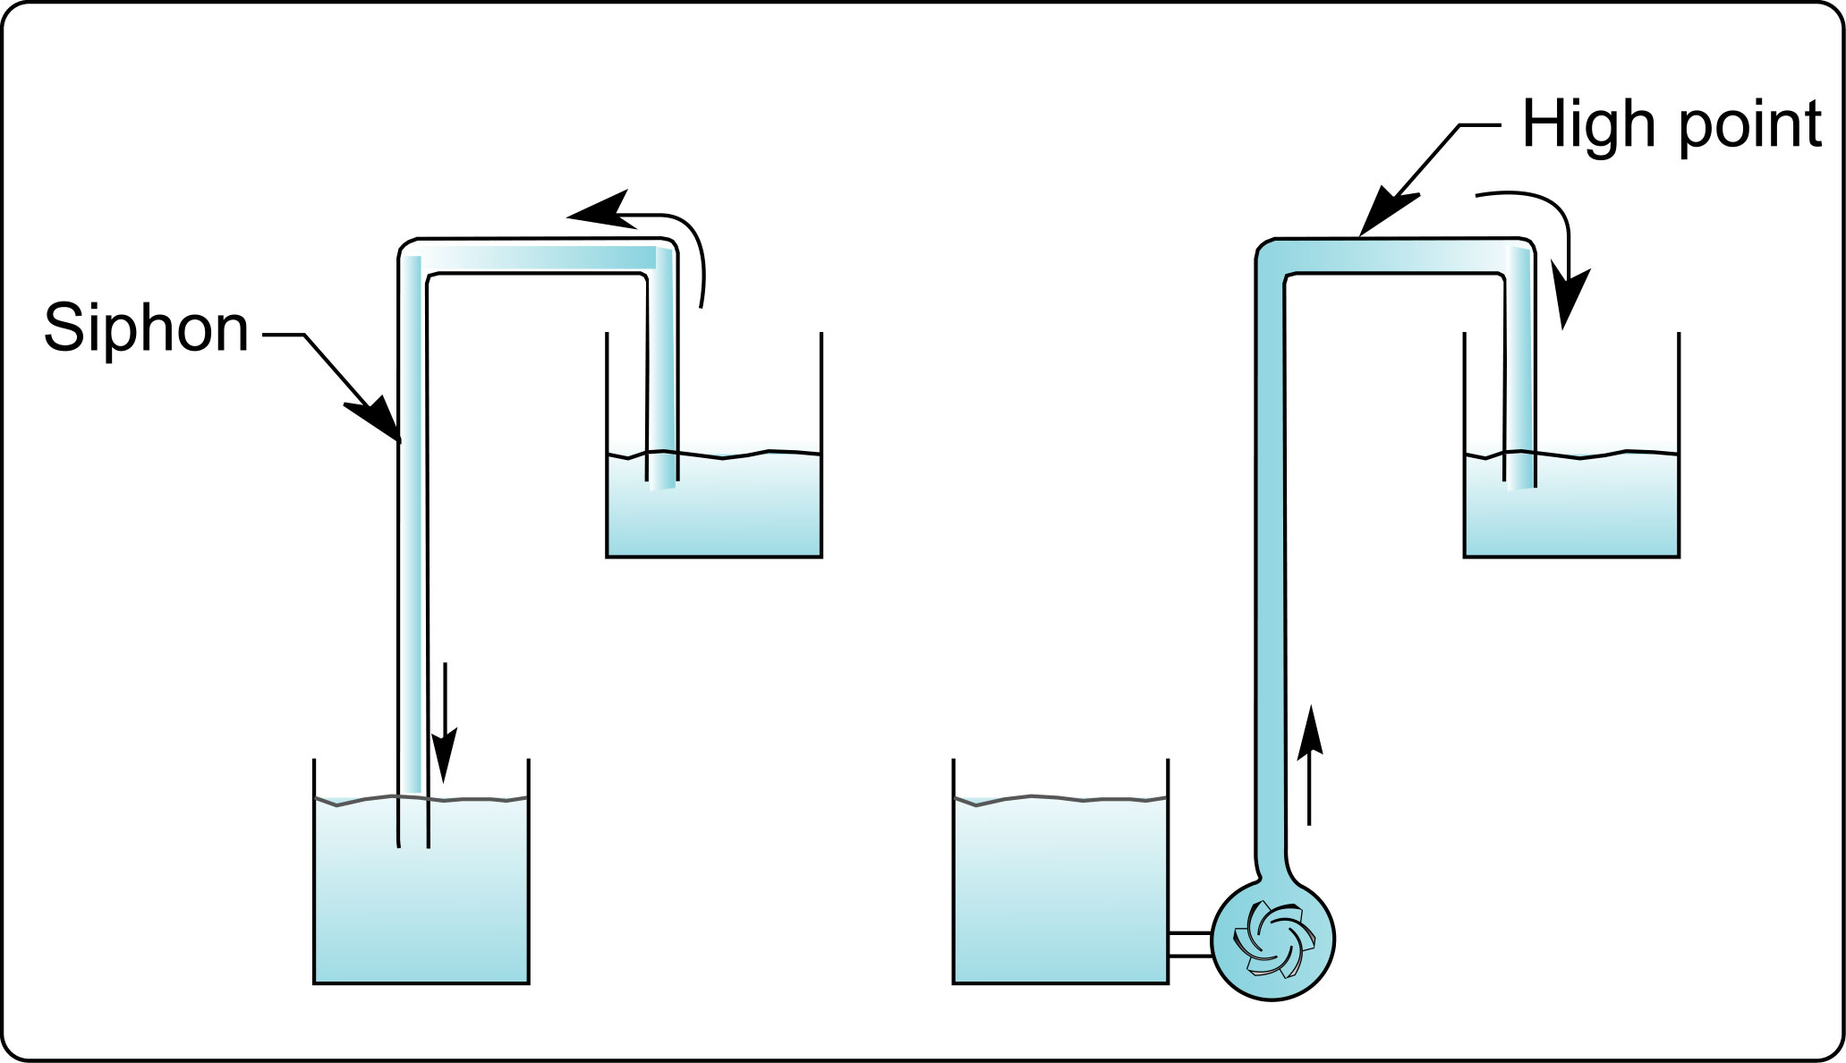
Figure 2 A typical pump system is a siphon in reverse.

I would like to make a clear distinction between 3 levels of pressure:

- pressure
- zero pressure or atmospheric pressure
- low pressure

The first level of pressure is the level that is meant when we say “The purpose of a pump is to produce pressure at its outlet” or “At the bottom of this tank, the fluid weight produces pressure”.
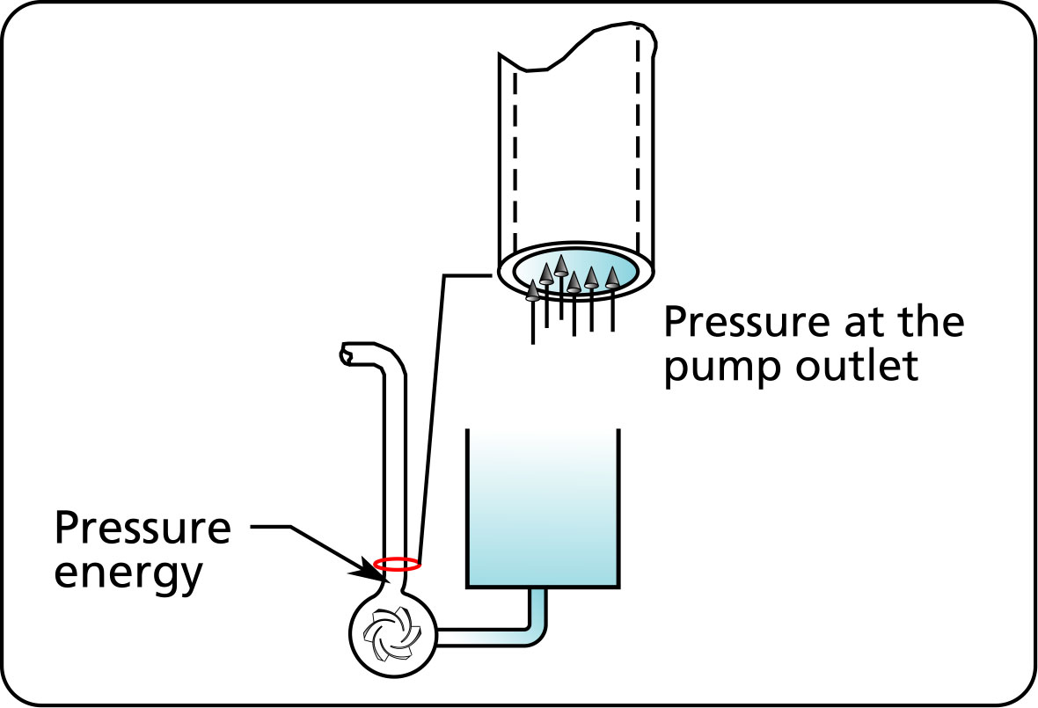
Figure 3 Pressure at the pump outlet.

Let’s take the example of pressure generated by fluid weight. Pressure can be thought of as small force vectors acting on very small surfaces. The sum of these small vector forces over larger areas produces a force which acts in a perpendicular direction to the surface of contact.

The weight of the water presses down on the bottom of the tank, producing these small force vectors that we call pressure. The sum of these force vectors gives us the larger force F which is the weight of the fluid. The pressure at the bottom of the tank is defined as the force or the total weight of this fluid divided by the surface area, in this case the surface at the bottom. Pressure is force divided by area.
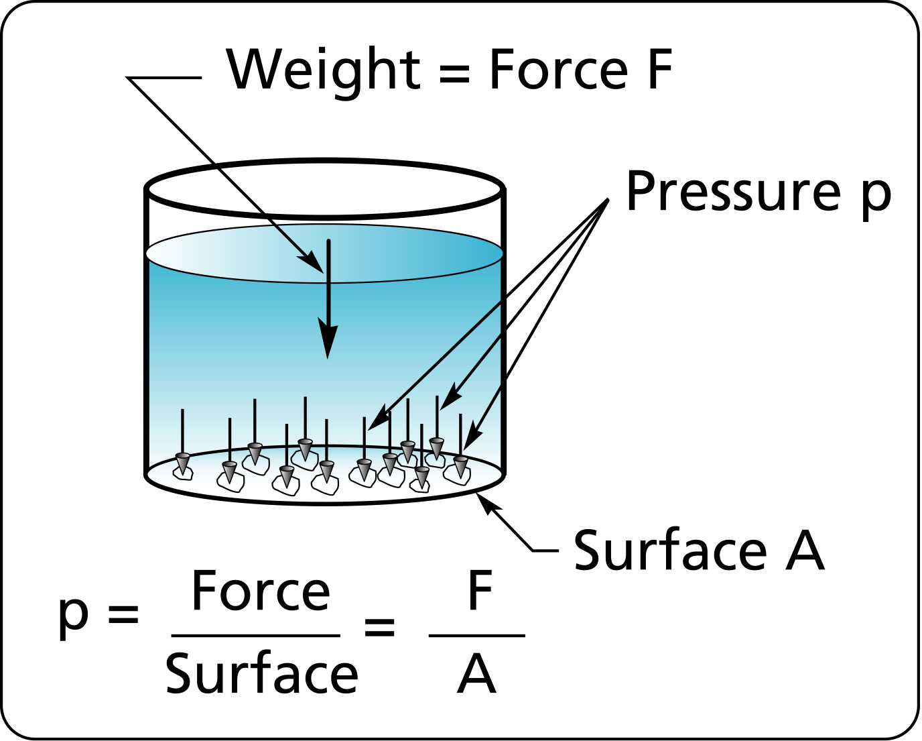
Figure 4 Pressure as seen small force vectors over small areas.

To put this in a practical context, as the level in a suction tank drops so will the pressure level at the inlet of the pump.

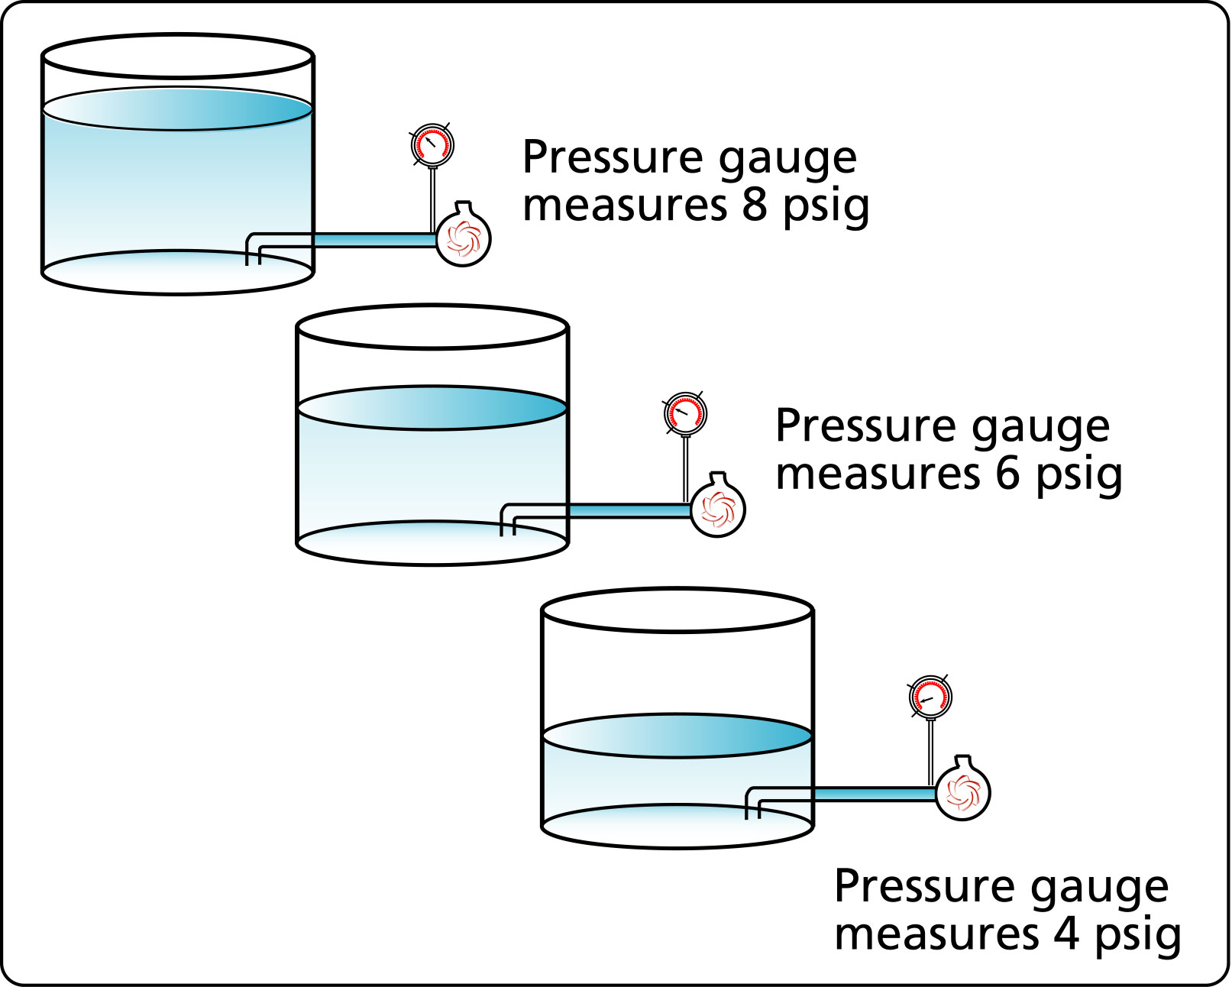
Figure 5 The pressure at the pump inlet varies as the level in the suction tank drops.

As the level drops further, the pressure at the pump suction will reach zero or the same as the local atmospheric pressure.

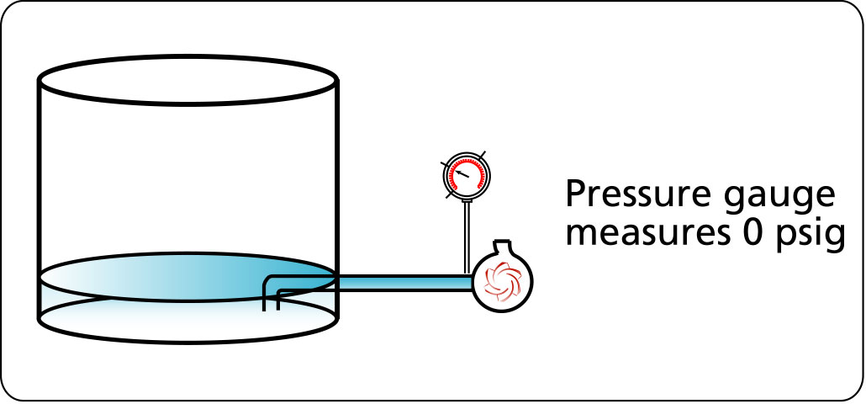
Figure 6 The pressure at the pump inlet is zero because the tank fluid level is even with the pump suction.

If the level drops further, we will have low pressure or pressure that is less that the local atmospheric pressure. On the psig scale of pressure, the pressure will be negative.

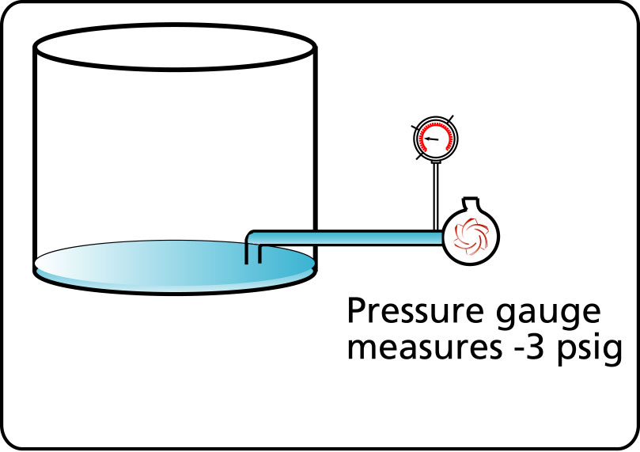
Figure 7 The level in the suction tank is lower than the pump inlet level producing low pressure at the pump inlet.

Pressure units

The psig (pound per square inch gauge) pressure scale is often used to measure pressure in pump systems. It is a relative measurement (relative to atmosphere) where 0 psig is equal to the pressure level in the local environment.

The psia (pound per square inch absolute) allows the measurement of pressures that are lower than atmospheric pressure. Zero psia is the lowest pressure possible and corresponds to a perfect vacuum.

The inch of mercury is often used as a unit to measure atmospheric pressure. A glass tube with the top end sealed is filled with mercury, the bottom end is resting in a bowl of mercury. Atmospheric pressure acts on the fluid surface of the bowl changing the height of the mercury level in the tube as the pressure in the environment changes. The height of mercury corresponding to atmospheric pressure at sea level is approximately 30 inches and this corresponds to 14.7 psia or 0 psig. The inch of mercury scale is also used to measure low pressures or pressure below atmospheric pressure.

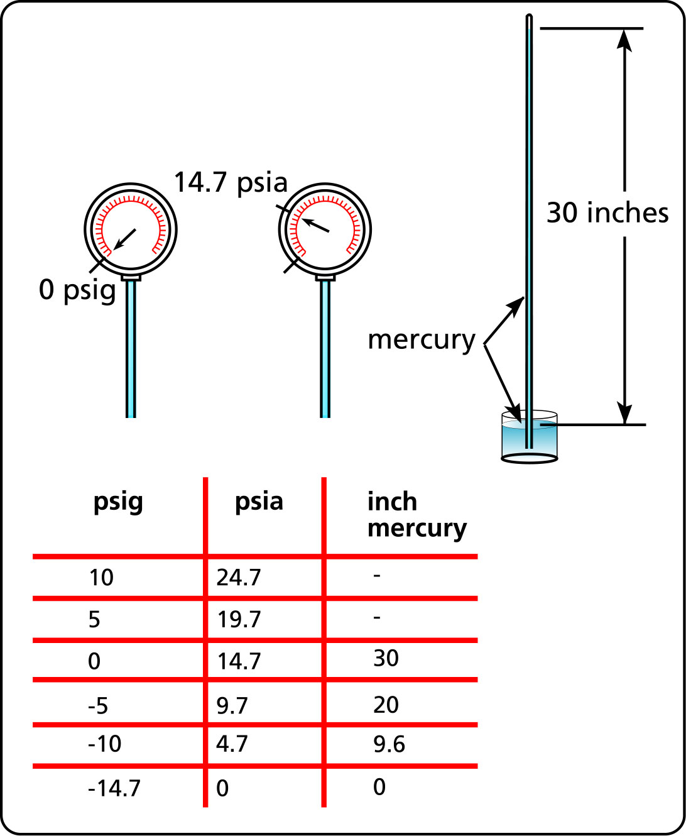
Figure 8 The different units used to measure pressure.

Atmospheric pressure
Atmospheric pressure is the pressure present in the local environment generated by the air that surrounds us. It is maximum at sea level and decreases with elevation since the density of the air decreases with elevation. For example, the air pressure in Mexico City, which is at 7000 feet in altitude is 3.3 psi less than the pressure at sea level.

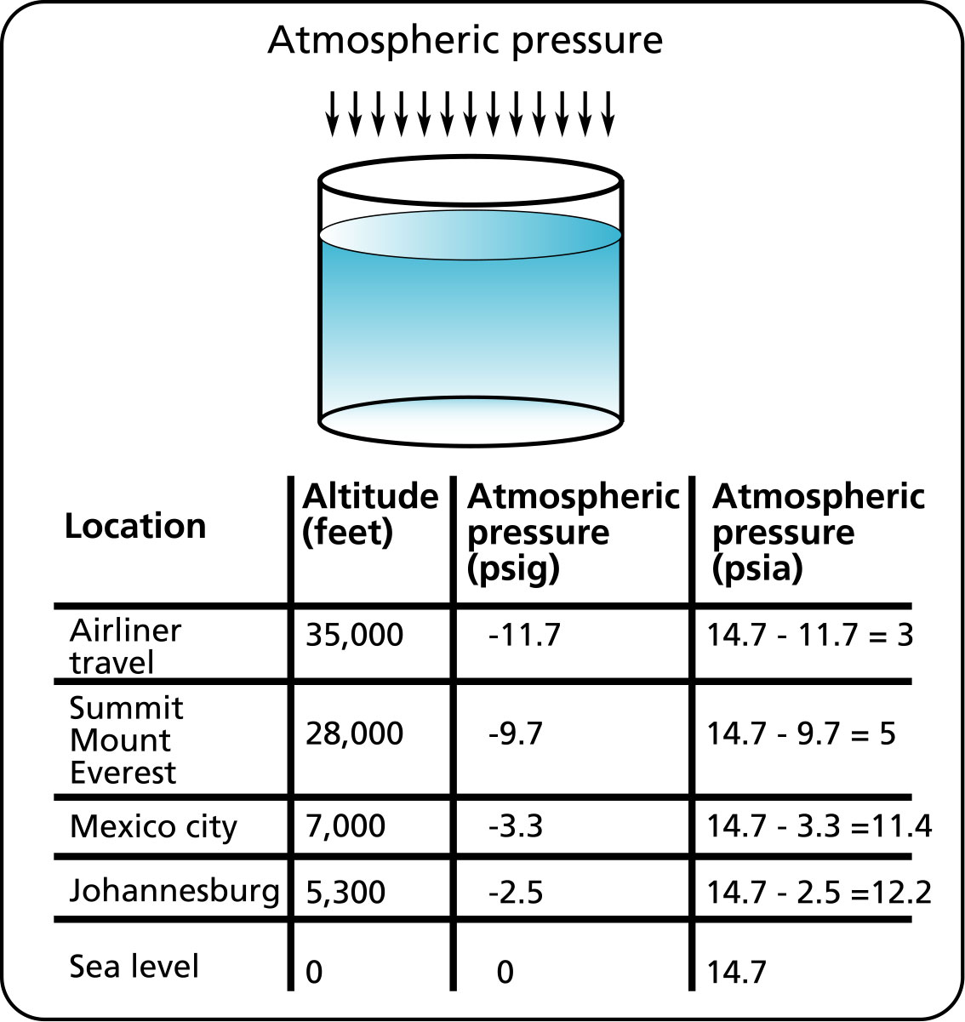
Table 1 Values for atmospheric pressure in various parts of the world.

Table 1 gives the air pressure in terms of psia and psig at different place and altitudes in the world.

Why is it important to know about atmospheric pressure? For 2 reasons:

- Pressure below atmospheric pressure is a vacuum which can allow air to enter the system and disturb the operation. For example, if the pressure at the pump suction is low due low level in the suction tank, or to improper sizing of the suction pipe, or plugging or other reasons, and if the pipe or fittings are damaged, then air will be sucked into the system.
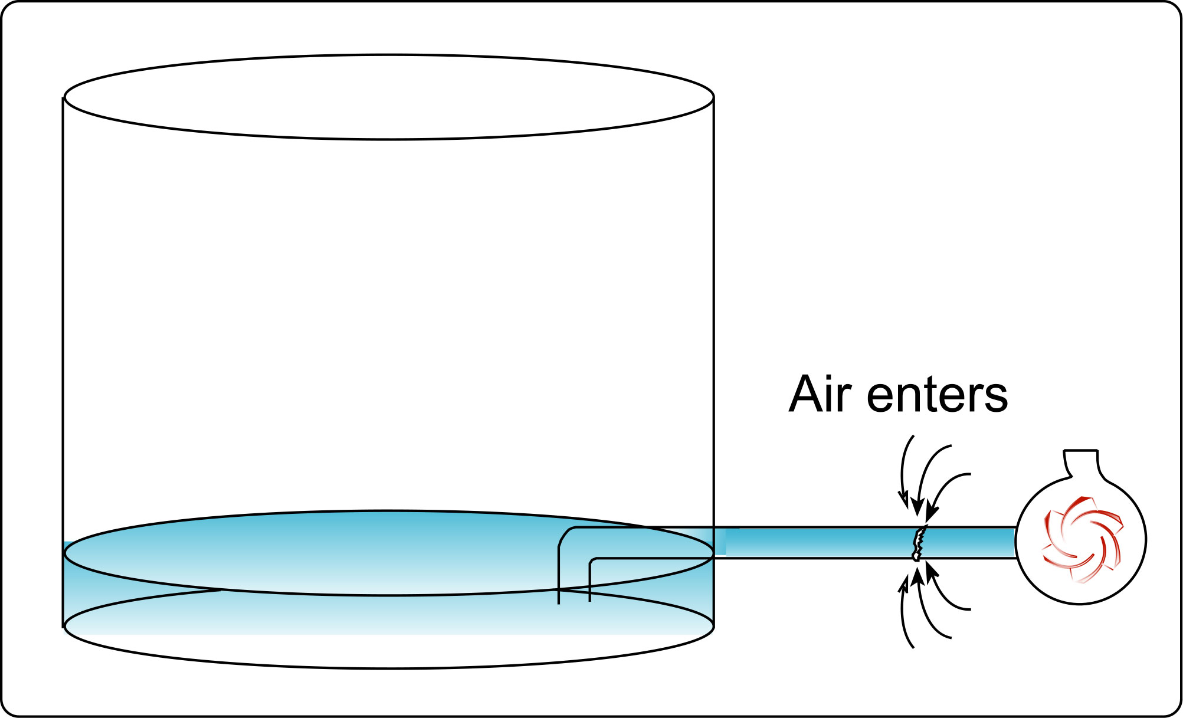
Figure 9 Air enters pump suction at a low pressure area due to damage.

2. The atmospheric pressure contributes to the amount of pressure energy available at the pump suction, if the atmospheric pressure is low due to high elevation for example, then the pressure at the pump suction is lower and this can affect the operation of the pump. For example, the pressure at the pump suction has been measured to be 19.7 psia for a pump located close to sea level. If this same system with the same amount of fluid in the tank were located in Mexico City where the elevation is 7000 feet, we would measure 16.4 psia because of the lower atmospheric pressure.
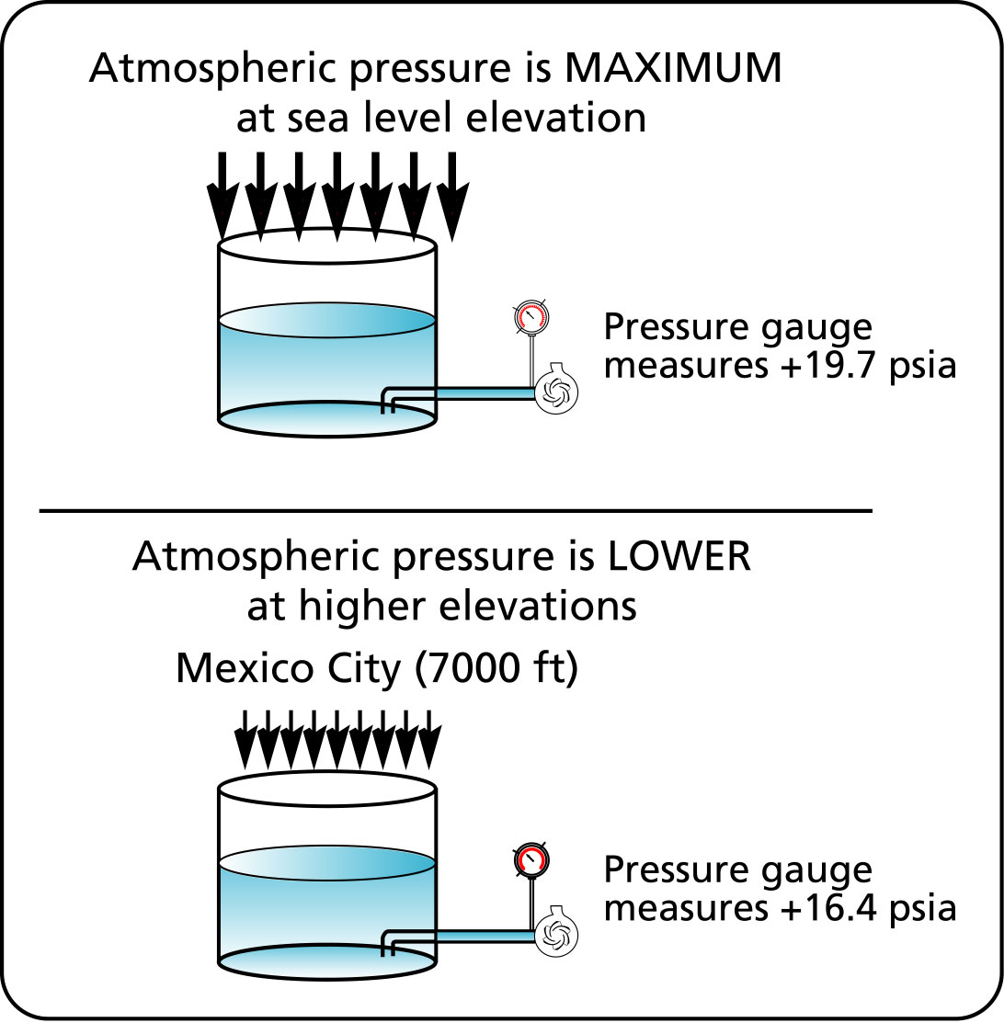
Figure 10 The effect of atmospheric pressure level on the pressure at the pump suction.

An experiment with atmospheric pressure

Very strong forces can be generated with atmospheric pressure as we will show with this experiment. Take an empty can of soda, put a half inch of water in the bottom and bring to a boil. Grab hold of the hot can with appropriate gloves, turn it upside down and immerse in room temperature water. The can will appear to crush itself.

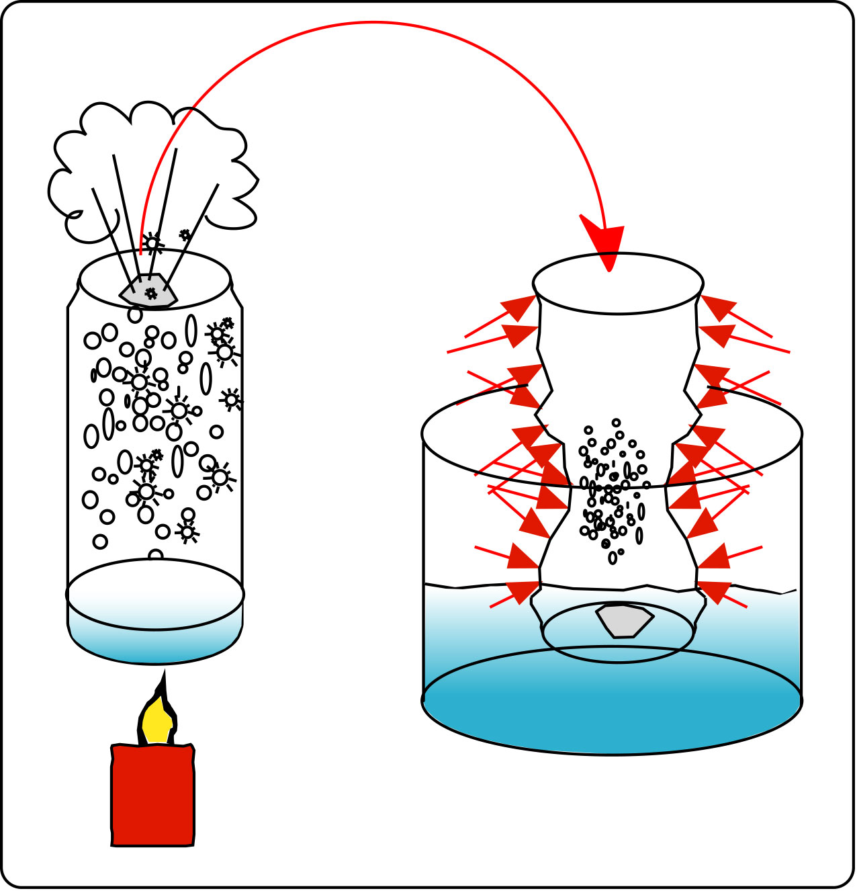
Figure 11 Atmospheric pressure can crush a soda can.

What’s happening? The boiling water in the can produces a hot gas. The volume that a gas occupies is proportional to pressure and temperature. For a constant volume, when the temperature increases, the pressure increases and when the temperature decreases, the pressure decreases. When the can is turned upside down and immersed in water, the volume of the hot gas is kept constant, and the temperature drops quickly due to the surrounding water causing the pressure inside the can to drop. Since the outside pressure is much greater, the can is crushed.

Low pressure
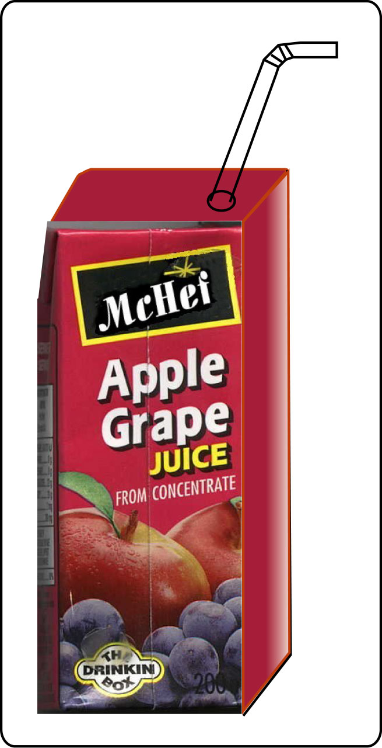
Figure 12 A typical cardboard juice box.
What is low pressure? Technically, low pressure is a pressure level that is measured in some area of a system that is lower than the local atmospheric pressure. Here is an example, get one of those cardboard juice boxes that are available in convenience stores. Because the straw goes through a hole in the box that is snug with the straw shaft, when juice is sucked out of the box the box collapses. The box volume is fixed, when you remove fluid from the box there are less fluid particles in the same volume and the pressure drops. Since the pressure inside the box is lower than the atmospheric pressure outside the box, the difference in pressure and the force they generate make the box collapse.

When the box is empty, you can duplicate this effect by removing the air in the box. We can suck the air out of the box and make the box collapse due to low air pressure in the box.

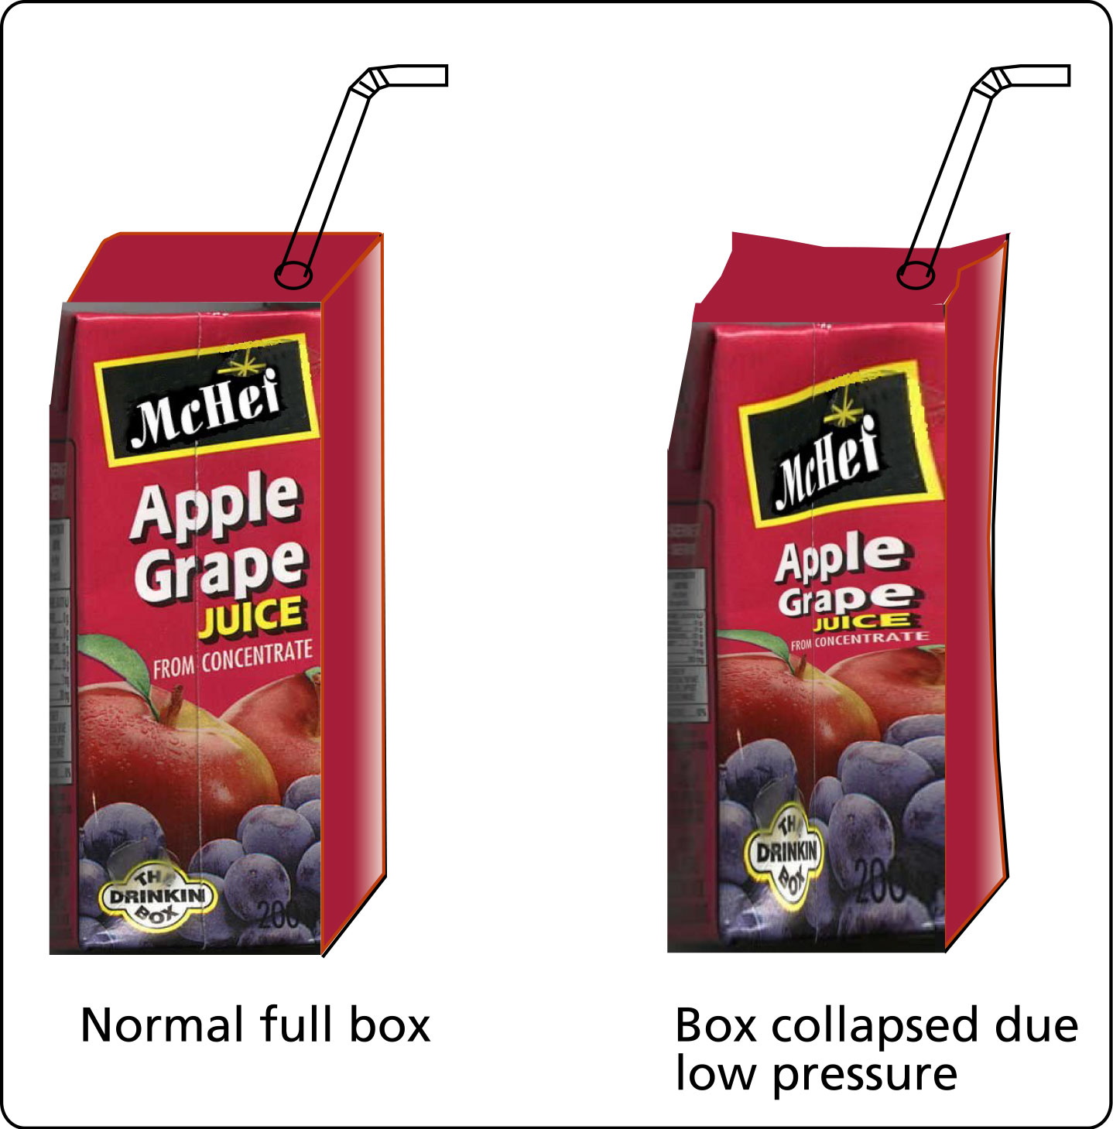
Figure 13 A full juice box at the same pressure as atmospheric pressure vs. a full juice box with the juice under low pressure and the box collapsed.

Fluids suspended within a tube

Imagine that we have fluid in a tube, we disconnect the fluid source, and lift one end up vertically. What happens to the fluid in the tube? It falls. The fluid falls because there is no net upward force to support the weight. The fluid in the tube is subjected to atmospheric pressure on each side. The forces generated by atmospheric pressure are equal and there is no overall upward net force to support the fluid’s weight, therefore it falls.
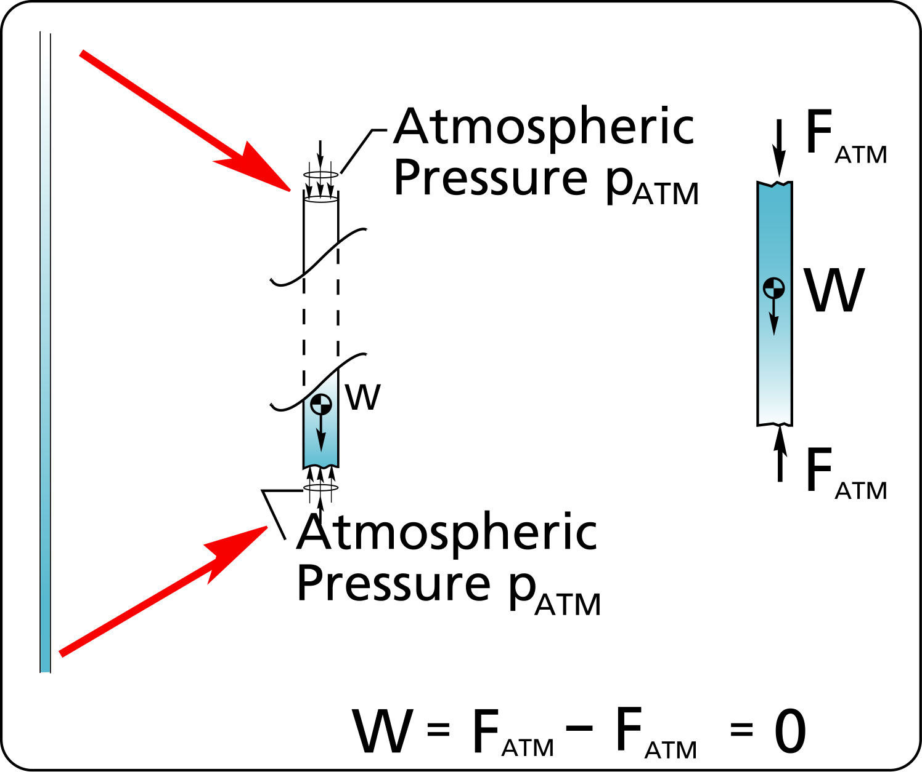
Figure 14 Fluid in an open tube falls due to lack of support.

We create relative low pressure everyday with a straw.
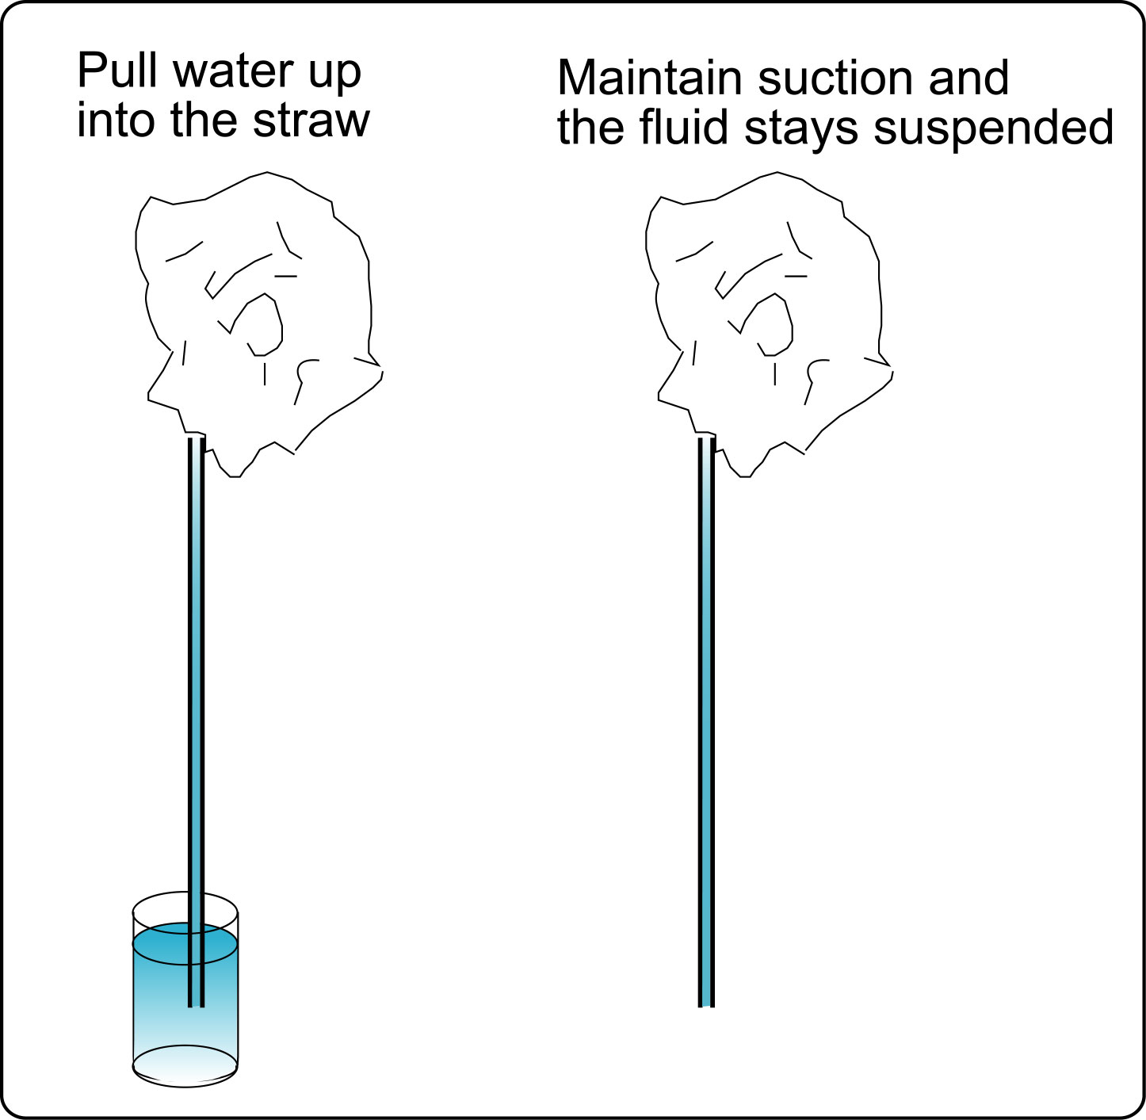
Figure 15 Fluid suspended in a straw while applying suction at the top end.

When we draw fluid up into a straw, we do it by creating low pressure at the top end of the straw. Try it, in fact see if you can find some straws with a flexible neck. If we keep providing the low pressure, we can remove the straw from the glass and keep the water suspended in the straw. The low pressure we generate at the top end of the straw holds the fluid in place.

For this next experiment, seal the bottom end of the straw with your finger and turn the straw upside down.

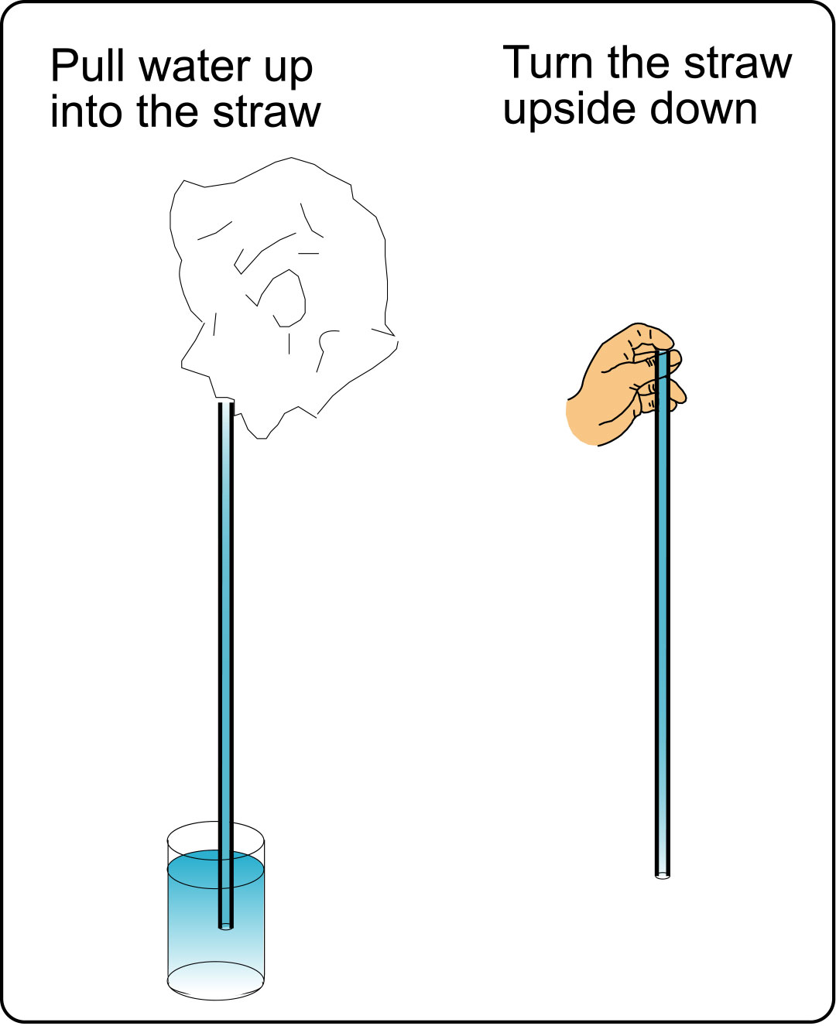
Figure 16 Fluid suspended in a tube with the top end sealed.

What happens? When we turn the fluid upside down low pressure is generated at the top end of the straw, the low pressure helps suspend the fluid. The low pressure is created by the weight of the fluid which tends to pull the fluid away from the top end or the finger. However as the fluid tries to pull away, it creates a lower pressure at the top end which tends to keep it in place.

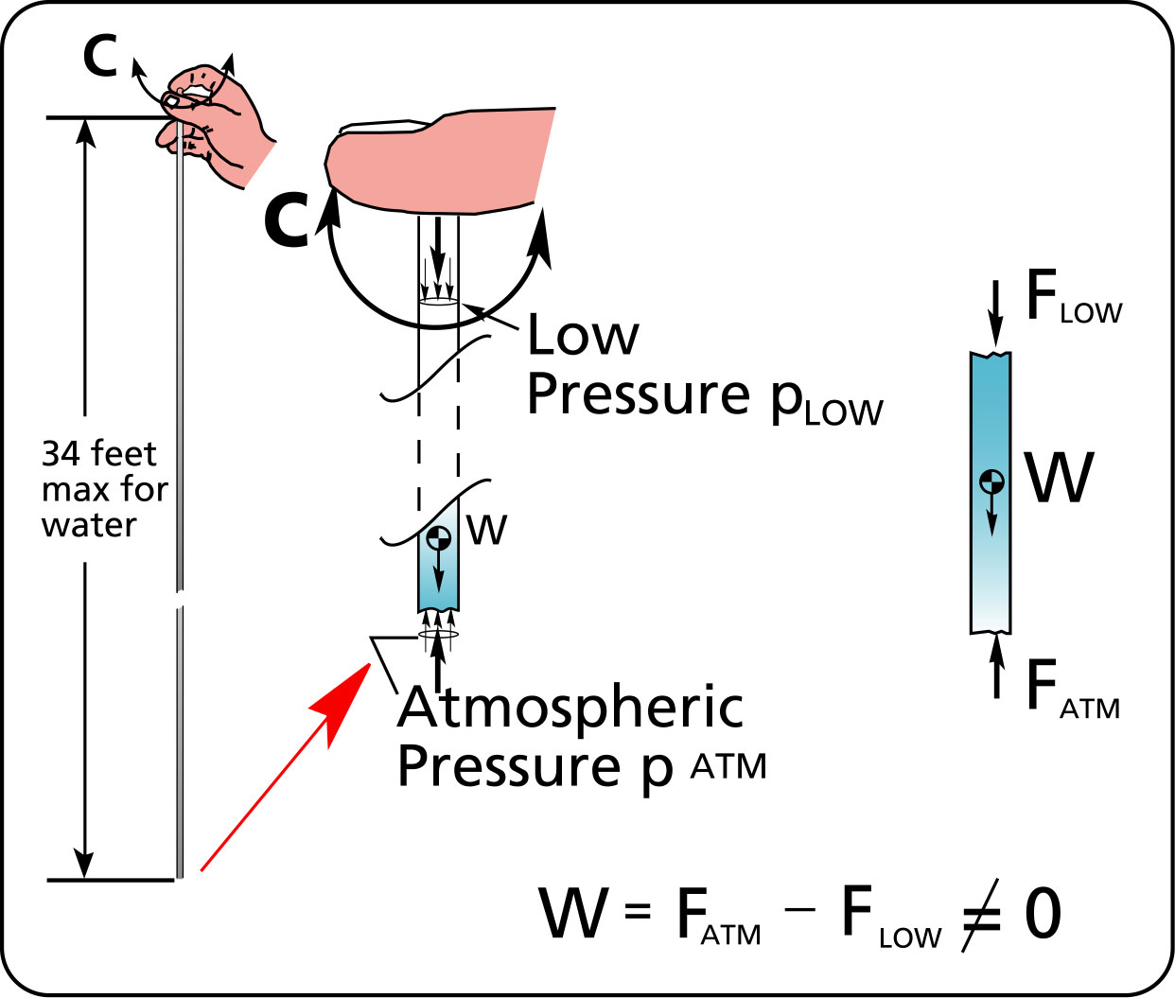
Figure 17 Fluid suspended with no apparent means of support within a tube.

Fluids can be suspended in a vertical tube if the top end is sealed. The pressure is lower on the sealed side vs. the open side of the tube. This difference in pressure generates a difference in the forces on each side of the fluid such that there IS a net upward force to support the fluid.

How long can the straw or tube be? At sea level, the tube can suspend a fluid column be 34 feet high.

Let’s do one more experiment with the straw.

Using the straw with the flexible neck, pull some water up into it and seal the bottom. Now turn the top part downward. Will the fluid stay suspended in the top part or will it fall out of the straw? Let’s find out.
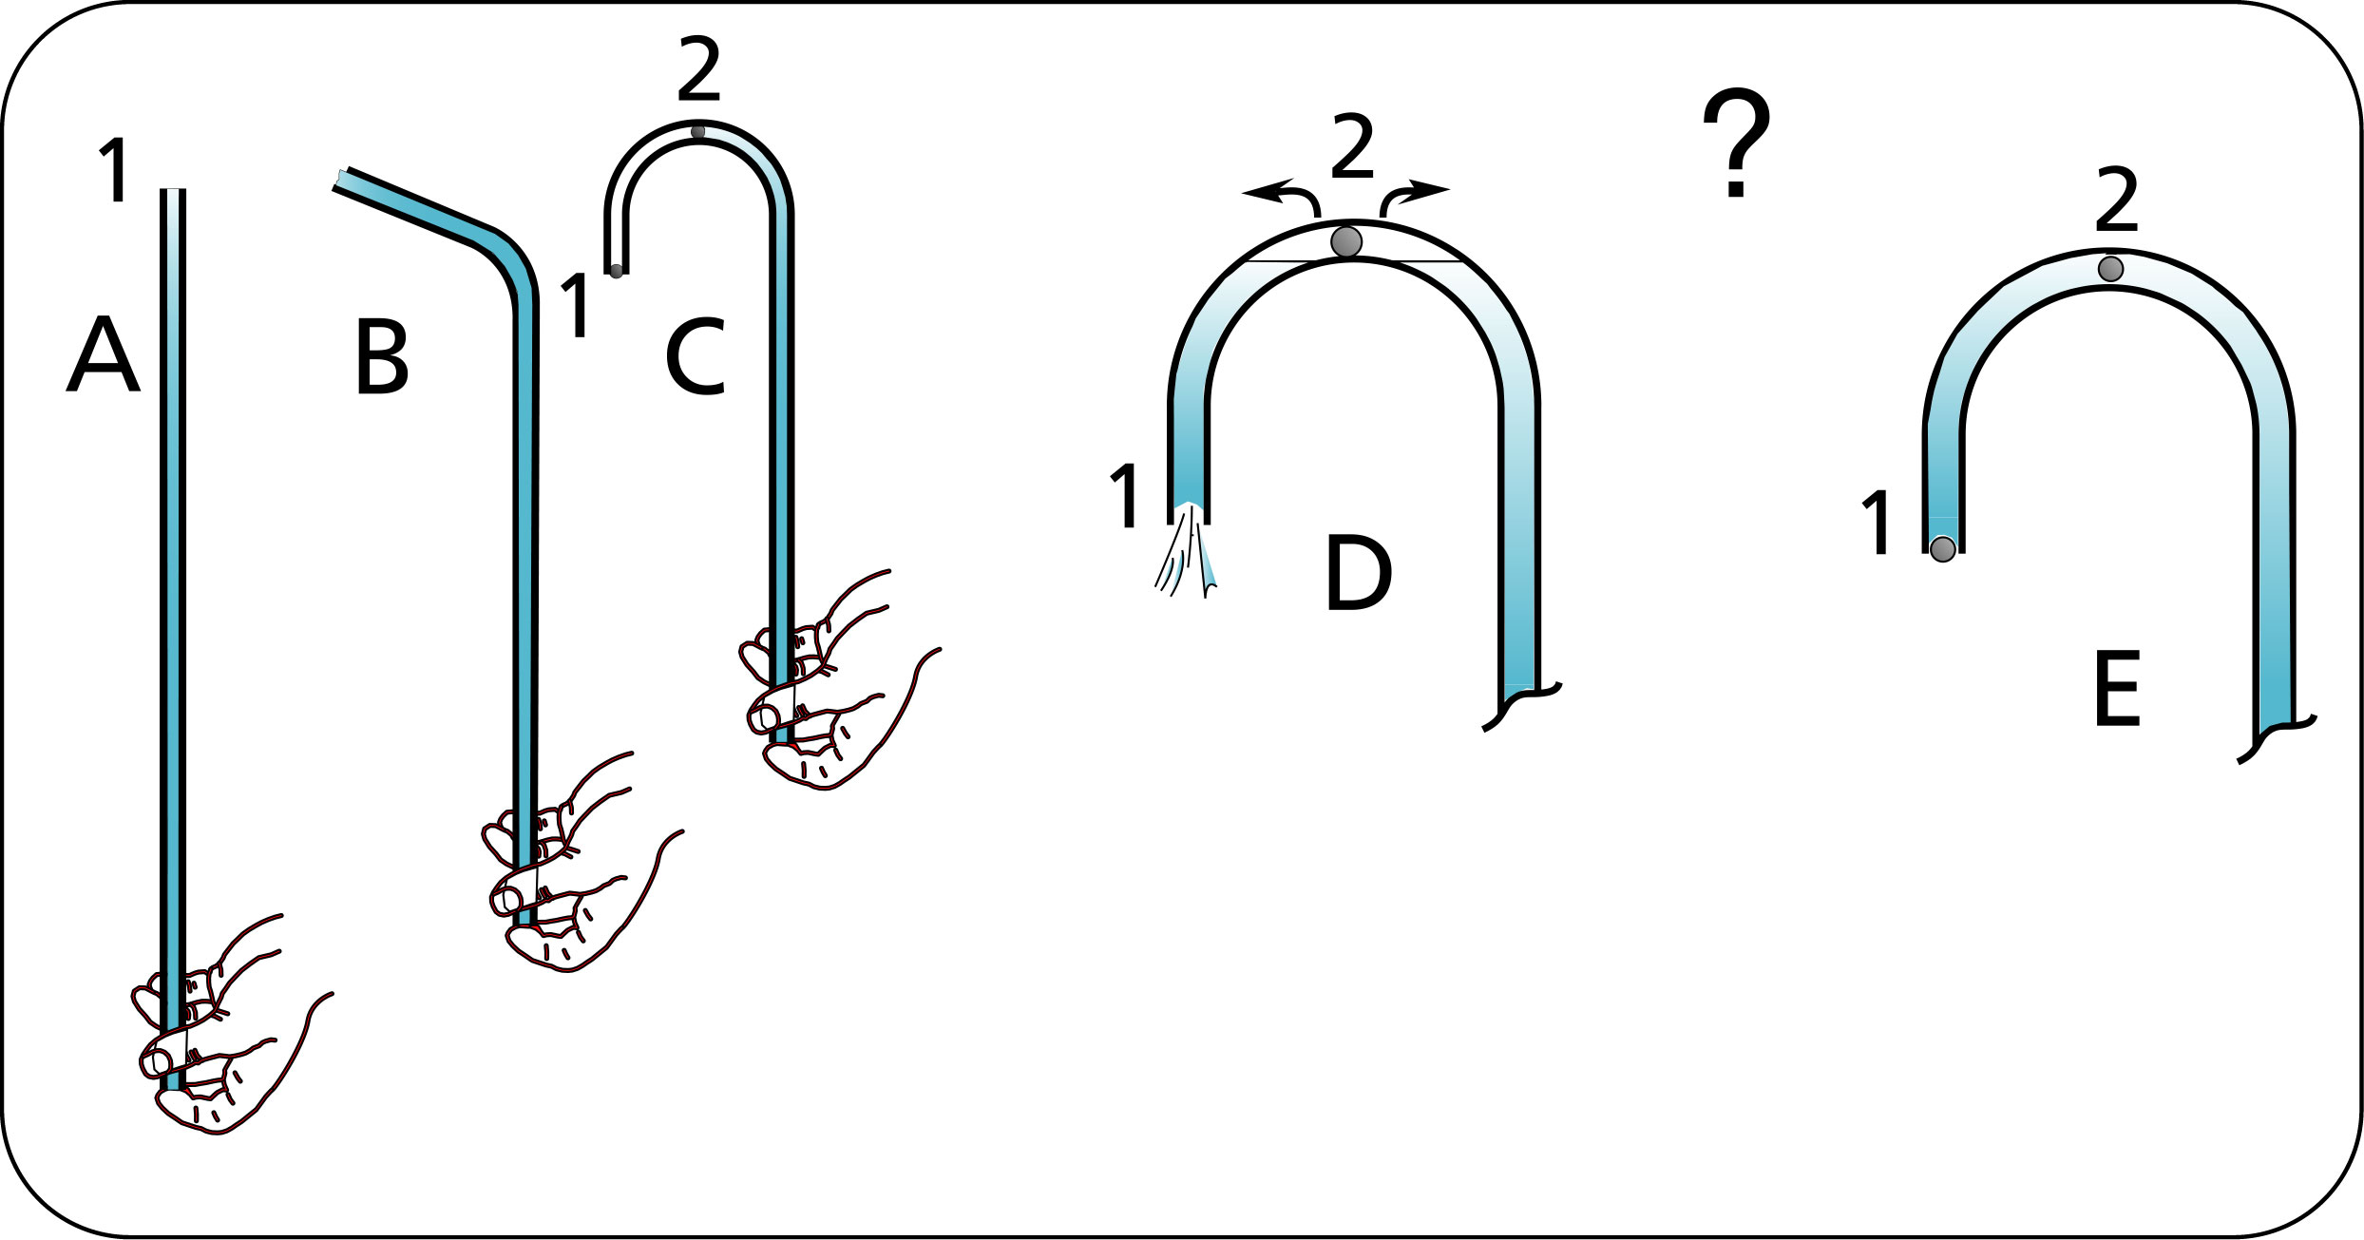
Figure 18 The bent neck straw experiment.

What’s happening. When the tip of the straw is turned downwards low pressure is created at point 2, the high point of the straw. This low pressure helps support the fluid between points 1 and 2.

Imagine that the fluid particles are beads strung on an elastic (see Figure 19). At position A, the pressure at point 2 is proportional to the height of fluid between points 1 and 2. When the straw tip is at position B, the pressure at point 2 has dropped because there is less fluid weight between points 1 and 2. At position C, the bent straw neck is horizontal, there is no pressure at point 2 since there is no fluid or weight above point 2. The pressure at point 2 is the same as the pressure in the atmosphere at the open tip of the straw.

Here’s where it becomes interesting. When the tip of the straw goes below the horizontal as in position D, what happens to the pressure at point 2? Keeping with our analogy that the fluid particles are connected between themselves as beads on an elastic, the water particles that are below the horizontal at the open end of the straw pull on the water particles that are at the top and this has the effect of lowering the pressure. If we lower the pressure below the level in the atmosphere, the pressure becomes negative with respect to the atmosphere. How much water can be suspended on the open side of the straw? As much as 34 feet before the elastic breaks. This analogy helps us to visualize how low pressure can be created at a high point that is sealed. The elastic in real fluids is actually very stiff so that there is little or no movement between the fluid particles.

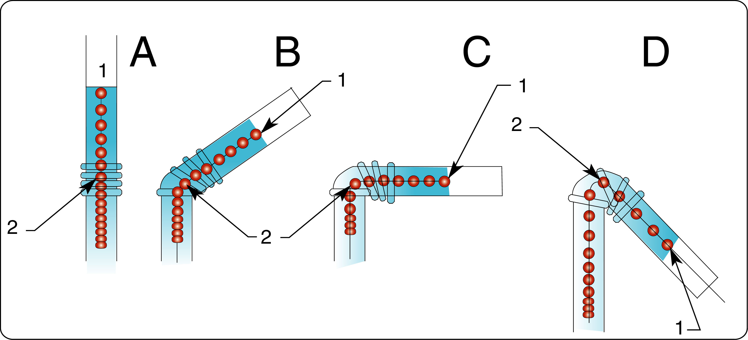
Figure 19 The bent neck straw experiment done step by step.

More fun with water

Get a piece of flexible tube, the kind you get at the tropical fish store, immerse it in water and try to lift it up so that it has a concave shape upwards. Try to keep both ends level so that the water stays in the tube. It’s very difficult if not impossible to do because there is always a little difference in the level of the two ends and the water drips out.
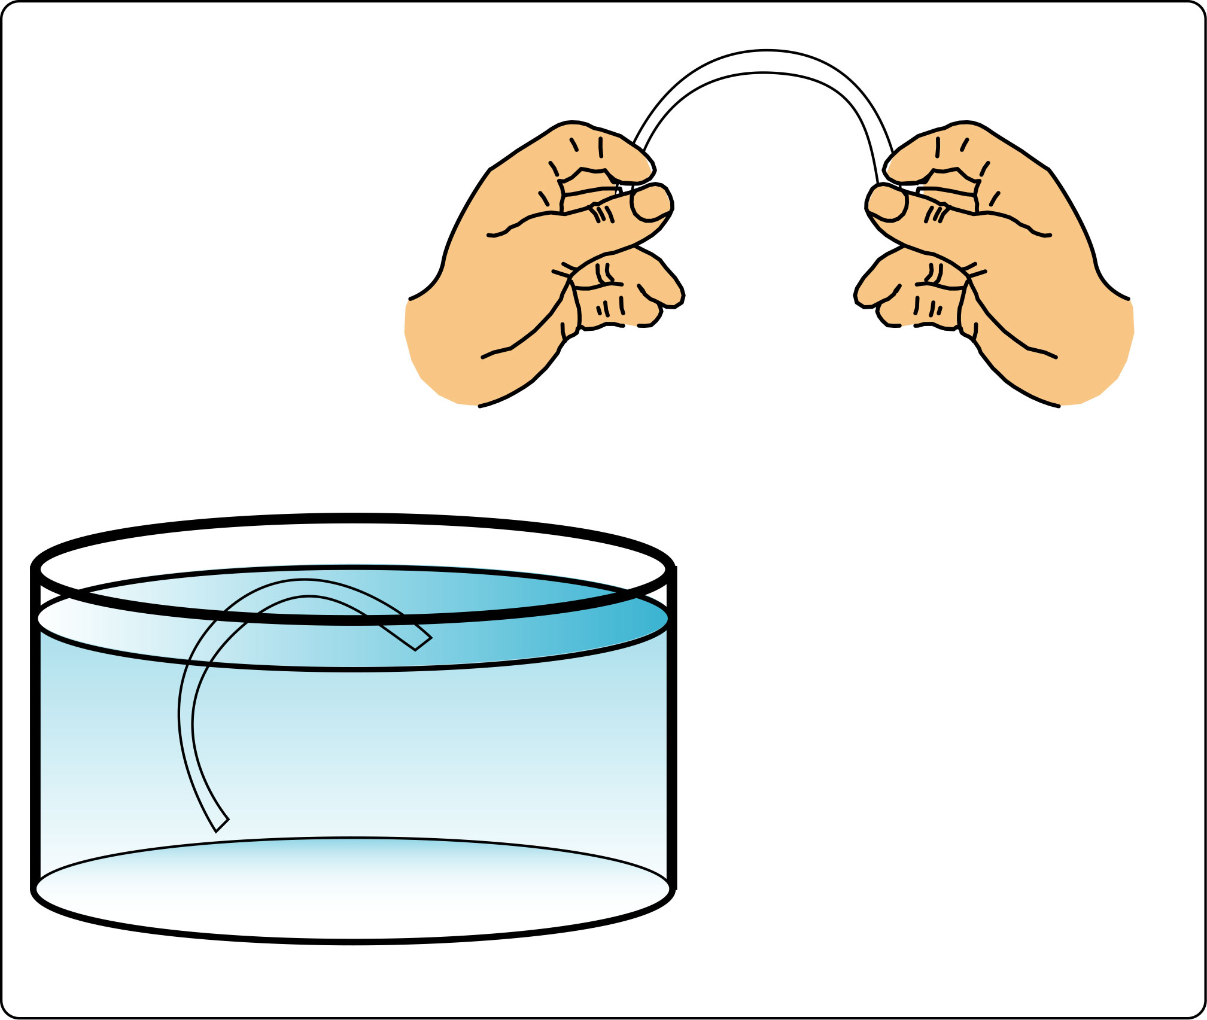
Figure 20 A tube filled with water is lifted into the air.

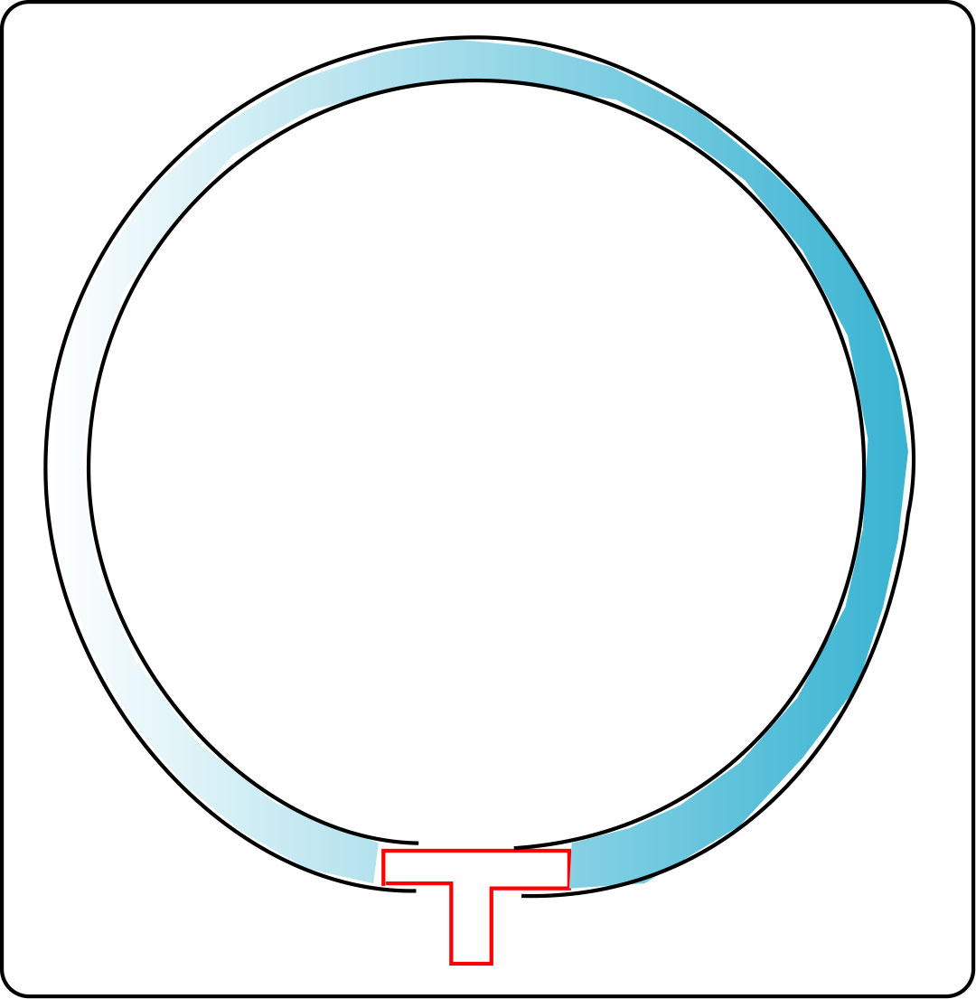
Figure 21 A tube full of water connected with a tee will keep its water no matter the orientation.

Now find a tee and connect the two ends of the tube. Make sure that the tee is completely open and free of obstruction. Instead of having two ends to this tube there is only one end so that it is impossible to have both ends at different levels. Now you can keep that water suspended no matter what the position of the tee. When the tee is at the bottom, just like in the bent neck straw experiment, low pressure will develop at the top which will help suspend the fluid.

Unfortunately small tees are difficult to find, but this experiment will work on a bigger scale, you can get some larger tube from the hardware store and a ½” or ¾” tees are readily available.

Back to the siphon

At first glance, a fluid moving vertically upwards without assistance creates a surprising effect. Figure 22 shows a comparison between the movement of a rope and that of a ball of the same weight. Both objects are solid, however the rope can emulate the behavior of a fluid where a ball cannot. A ball moves toward an incline and encounters a rise before it gets to a sharp drop; can it get over the hump without any intervention? No, not if it has a low velocity. Imagine the ball stretched into the shape of a rope, lying on a smooth surface, and draped across the hump. Even when starting from rest, the rope will slide down if the friction is not too high and drag the overhung part along with it. A fluid in a tube will behave in the same way as the rope. A rope is held together by fibers that are intertwined, fluid particles are held together by pressure.

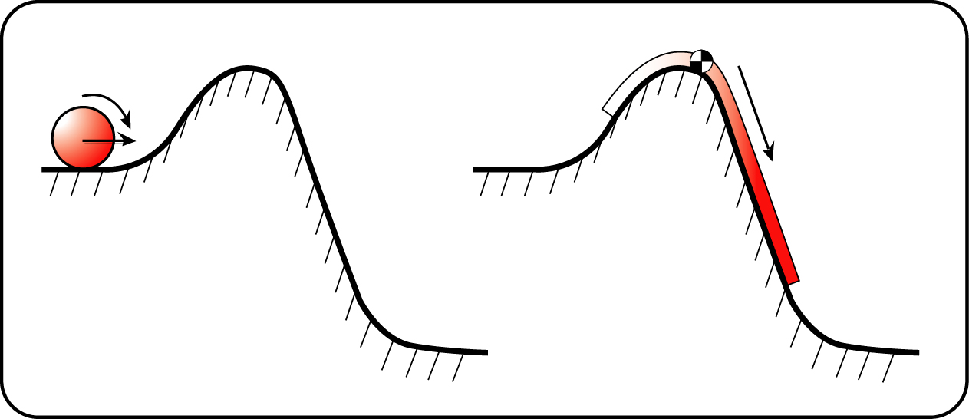
Figure 22 A siphon as a rope.

We create relative low pressure everyday with a straw. Low pressure is any pressure level that is below the local atmospheric pressure. Find some flexible tubing and try the experiment shown on Figure 23.

Get a small container and a short length of clear plastic tube. Our goal will be to put some water on a shelf so to speak.

1. Suction is applied to the tube and the liquid is lifted up to point 4.

2. Bend the tube as you apply suction to get the fluid past point 5. At this point a siphon is established and the fluid will start to flow.
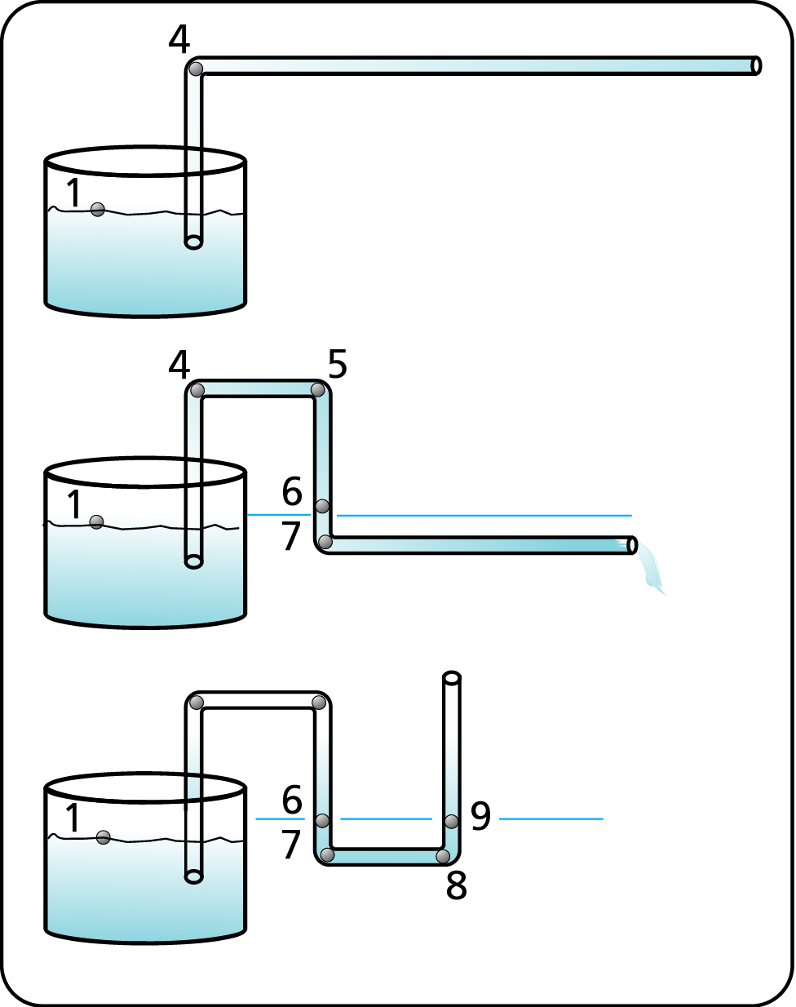
Figure 23 Creating low pressure.
3. The tube is bent at points 7 and 8 and the liquid level establishes itself at point 9, which is the same level as point 1.

The liquid in the tube remains stable and suspended at the level of point 4 and 5. Liquid has been raised from a lower elevation at point 1 to a higher one at point 4, like putting a book on a shelf. If the tube was punctured at point 4 or 5, what would happen? Air would enter the tube and the liquid would drop to its lowest level.

We have managed to create low pressure at point 4, which is easily maintained without further intervention.

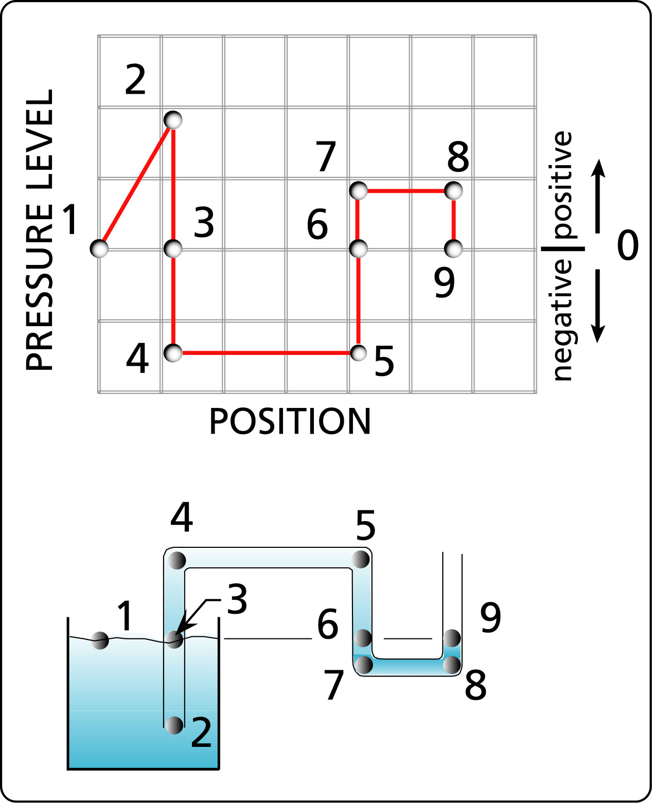
Figure 24 The pressure variation in a siphon tube whose entry and exit point are at the same level.

It Is interesting to see that even in a simple system such as this the pressure throughout the system varies considerably. The fluid particles between points 4 and 5 are under low pressure.

Remember that two conditions define a siphon:

- the inlet is higher than the outlet
- a portion of the pipe is higher than the inlet.

A siphon has the ability to lift fluids higher than its inlet point without the use of a pump.

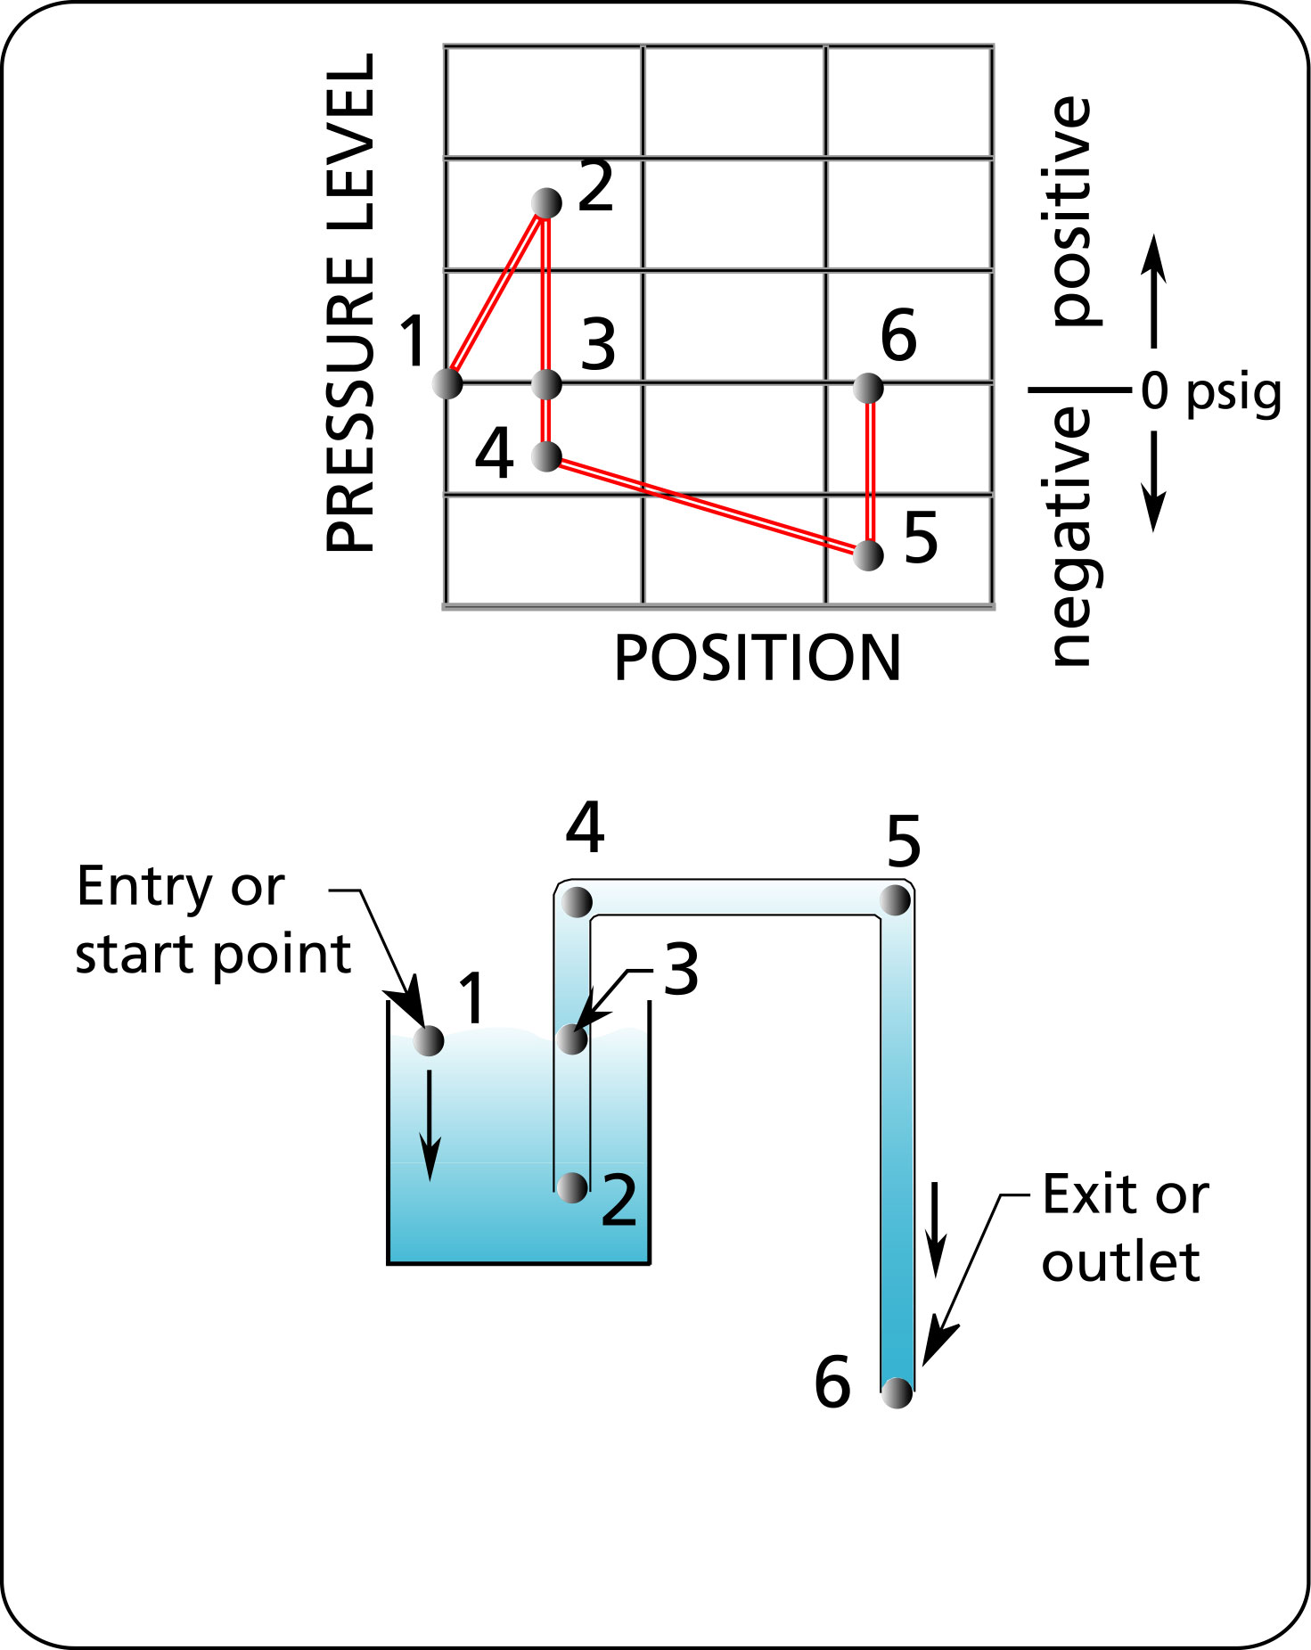
Figure 25 The siphon effect.

This remarkable behavior is due to low pressure at the top portion of the pipe. How so? The fluid is drawn into the pipe at point 2, and moves upwards to point 4. We know from the straw experiment that the only way for the fluid to stay suspended is if we have low pressure at point 4. The only difference between the siphon and the straw experiment is that the fluid in the siphon is moving. The pressure stays low all the way until we get to point 6, the outlet, where it becomes equal to the atmospheric pressure.

The difference in height between points 1 and 6 provides the energy to move the fluid.

A siphon provides a mechanism by which we can empty a tank to a lower level. If a pump is connected to the lower part of a siphon we can transfer fluid from a lower level to a tank at a higher level. This is the same situation as the siphon except that flow is reversed. The pressure level in the top part of the pipe will be the same as in the siphon. Therefore expect low pressures in the top part of a pipe when it enters a tank from above.

Figure 26 Low pressure at the high point of a typical pump system.
You are probably thinking: well of course there is low pressure at the top, the end of the pipe is submerged. That’s true, but there will be low pressure at the top whether the pipe is submerged or not. There is low pressure at the top because there is a portion of the fluid that is higher than the outlet which is at atmospheric pressure.
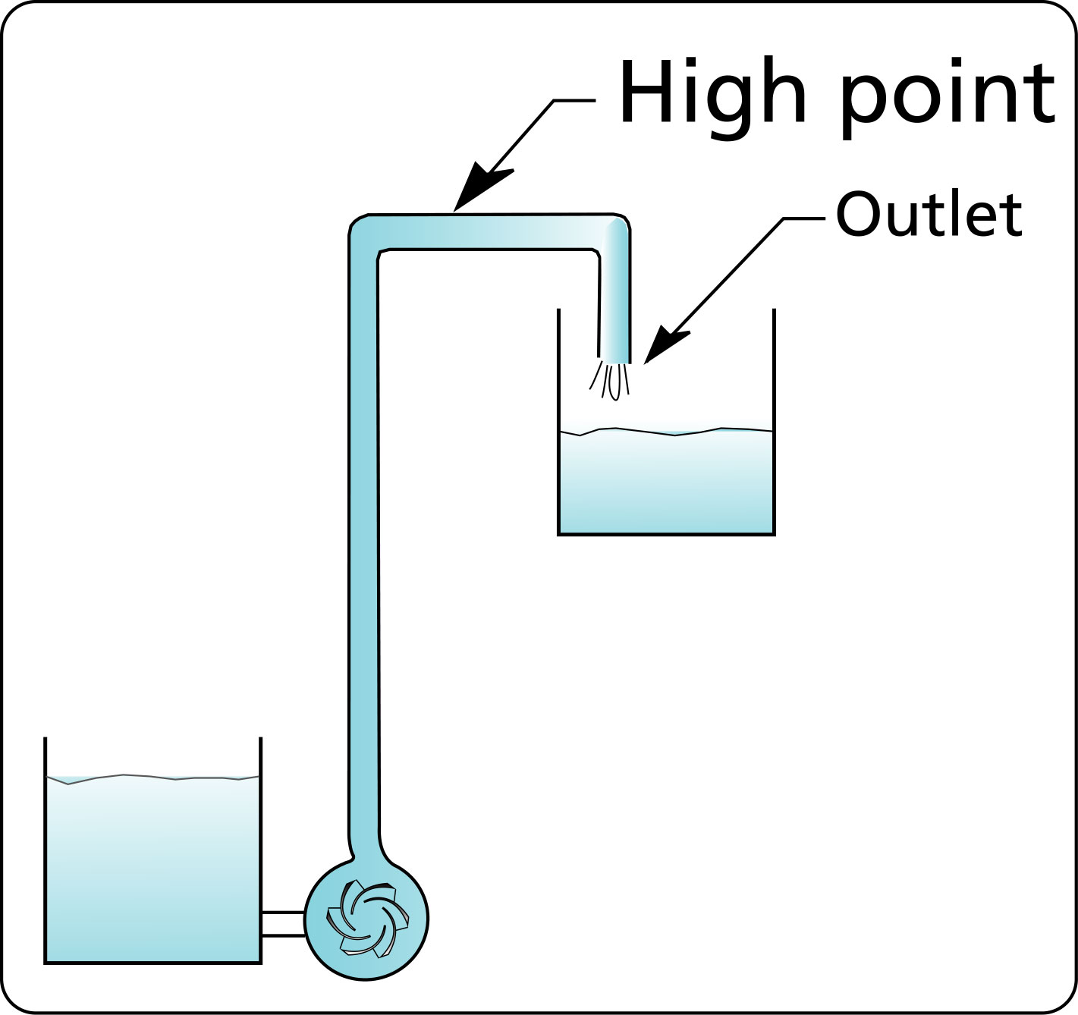
Figure 27 Low pressure at the high point of a typical pump system even when the pipe end is not submerged.

Why is this important?

As mentioned before low pressure can cause air to be sucked into the system if that area is damaged or cracked.
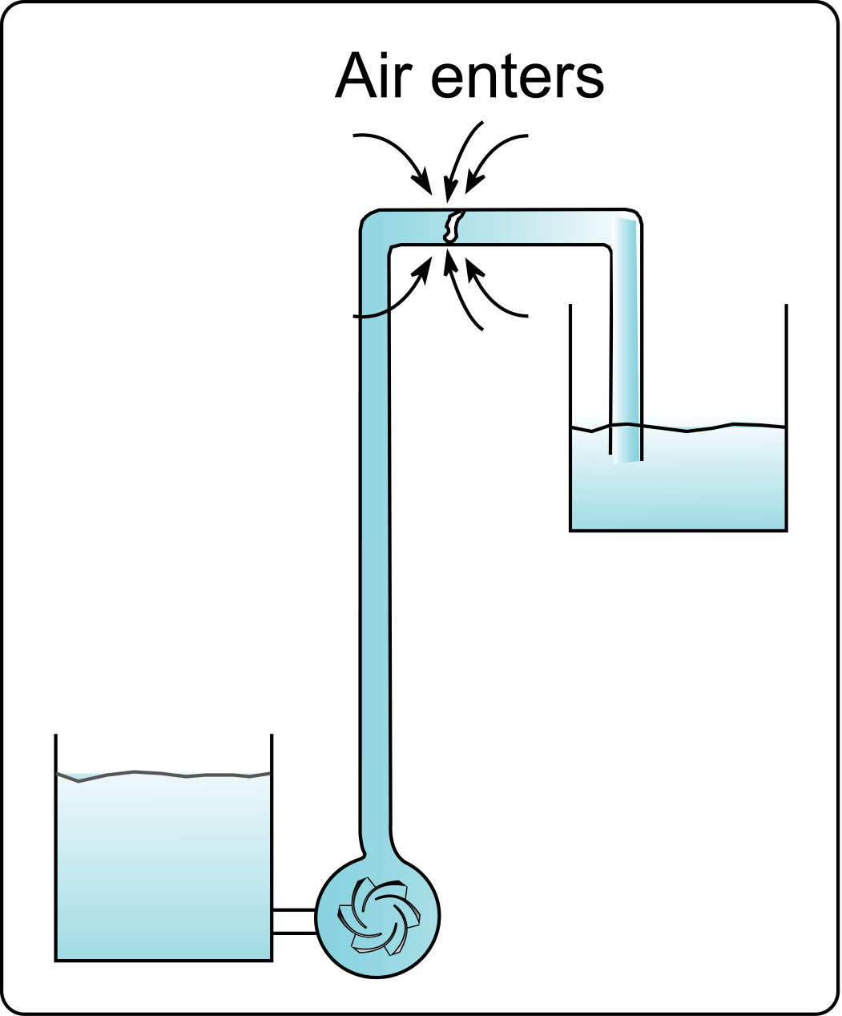
Figure 28 A cracked pipe at a low pressure area allows air to enter the system.

Also, if you try to add a connection at this point to supply fluid to another area of the plant, you will find that no fluid will ever leave that connection because of the low pressure.
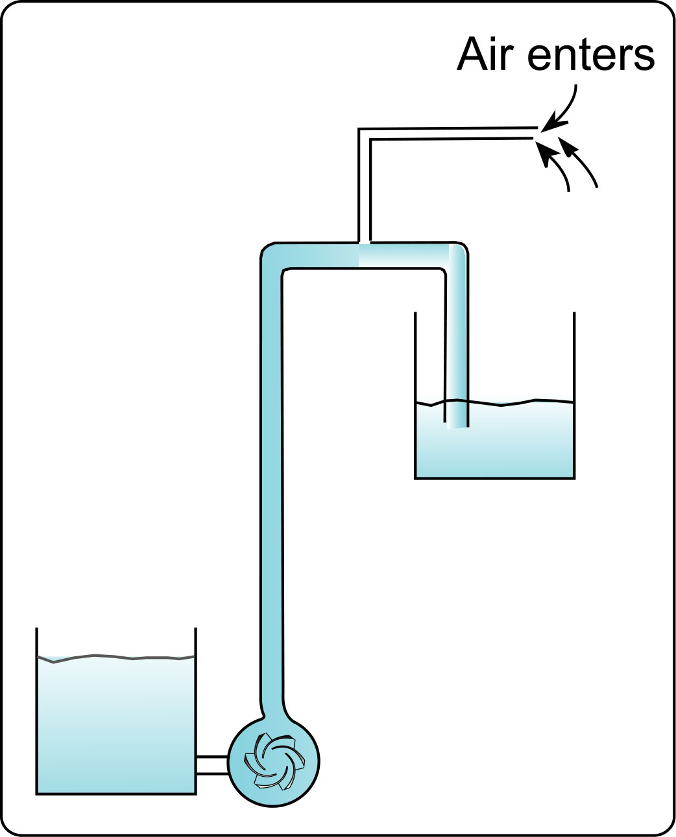
Figure 29 A new branch at a low pressure area does not allow fluid out.

Ever wonder why control valves that are positioned at the top of a piping system and near the pipe outlet tend to cavitate?

Before I answer this, a few words about cavitation. What is cavitation? Cavitation manifests itself audibly as a grinding noise, a noise that closely resemble gravel being moved around in a cement mixer. It can be heard at pump inlets and control valves. It is due to the fluid being vaporized because of low pressure (I will save this topic for a future article) and then suddenly collapsing due to high pressure produced by a pump impeller for example or the increase in pressure that occurs at the outlet of a control valve.

So why is a control valve in the position that I just mentioned susceptible to cavitation? Because at that position the pressure at the inlet of the valve is low, it is further reduced as the fluid goes through the body of the valve and the fluid boils. The small vapor bubbles that are produced are rapidly compressed and collapsed due to the increase in pressure as it comes out of the valve. This collapse produces a shock wave that impacts the valve body producing noise and severe erosion.

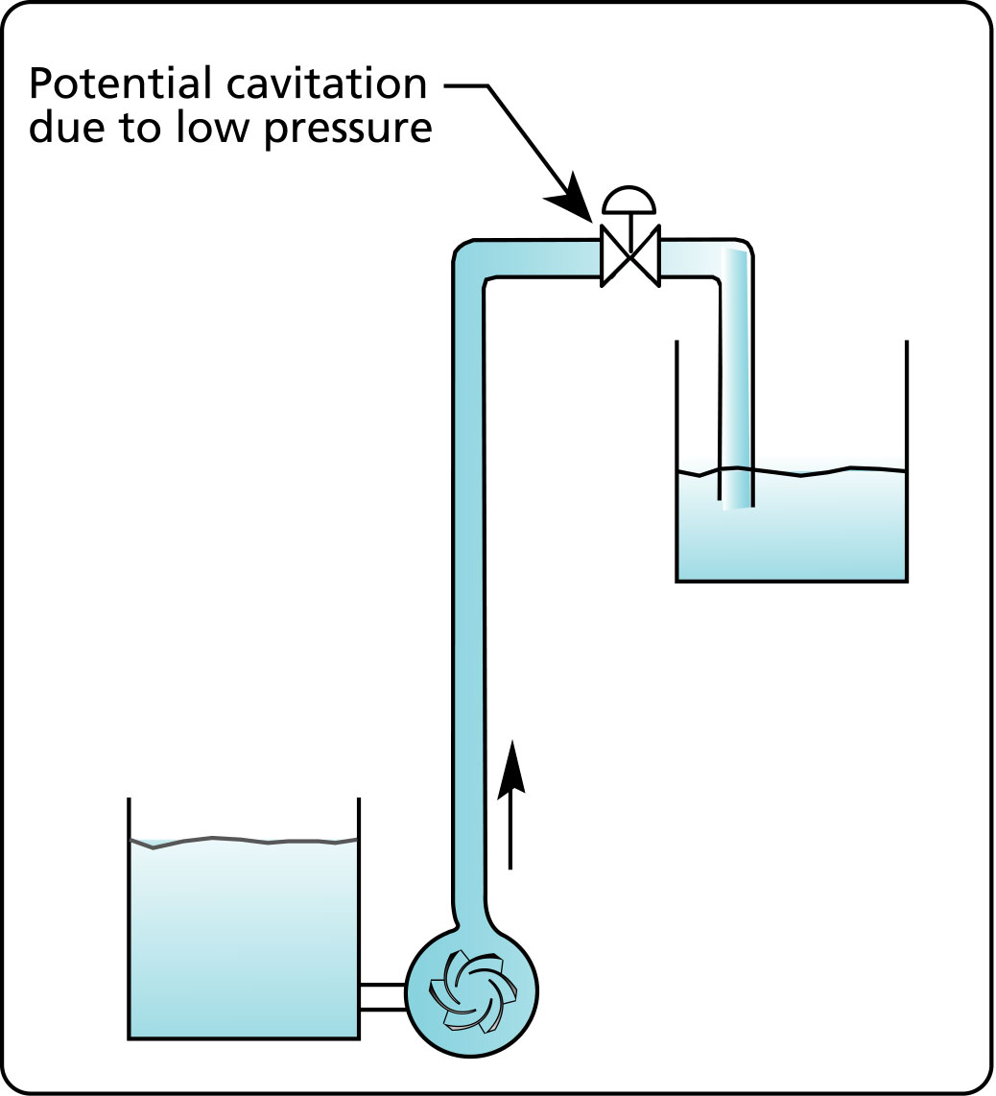
Figure 30 Low pressure at the inlet of a control valve can cause cavitation.

